**ASSIGNMENT I**

**Problem Statement**

Assignment to understand basic syntax of LEX Specifications, built-in functions

and Variables.

**Objective**

To understand the LEX syntax.

**Theory**

**LEX format:**

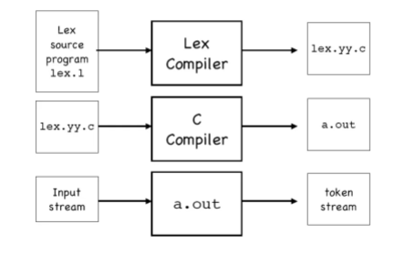

**LEX Specification:**

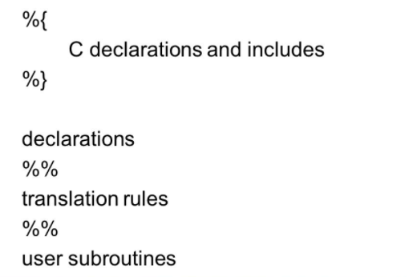

1. Write a program to find out whether given input is a letter or digit.

**Solution: lex1.l**

%{

%}

letter [a-zA-Z]

digit [0-9]

id2 {letter}({letter}|{digit})*

num {digit}("."({digit})+)?

%%

"if"|"else"|"while"|"for" {printf("keyword");}

{num} {printf("num");}

{id2} { printf("id2 "); }

%%

int main()

{

yylex();

return 0;

}

**Execution:**

1. flex lex1.l

2. cc lex.yy.c -lfl

3. ./a.out

2. Write a program to find out whether given input is a noun, pronoun,verb, adverb, adjective or preposition

**Solution: lex2.l**

%{

/*This sample demonstrates a word as a verb/ not a verb */

%}

%%

[\t]+ /*Ignore whitespaces*/;

is|

am |

are |

is|

were |

was |

be|

being |

been |

do|

does |

did|

will|

would|

should|

can|

could|

has|

have|

had|

go {printf("%s: is a verb\n",yytext); }

[a-zA-Z]+ {printf("%s: is not a verb\n",yytext); }

.|\n { ECHO:}

%%

main()

{

yylex();

}

**Execution:**

1. flex lex.l

2. cc lex.yy.c -lfl

3. ./a.out

**Note :** Extend this program to include noun, pronoun, adverb,adjective or preposition.

**ASSIGNMENT II**

**Problem Statement**

Implement Lexical analyser for sample language using LEX with error handling. (Subset of C).

**Objective**

To understand how to build a Lexical Analyser.

**Theory**

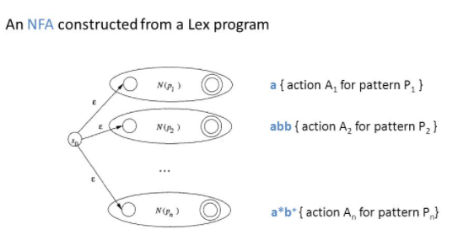Step 1: Construct ε-NFA from the Regular Expressions

Step 2: Convert ε-NFA to DFA using Subset Construction.

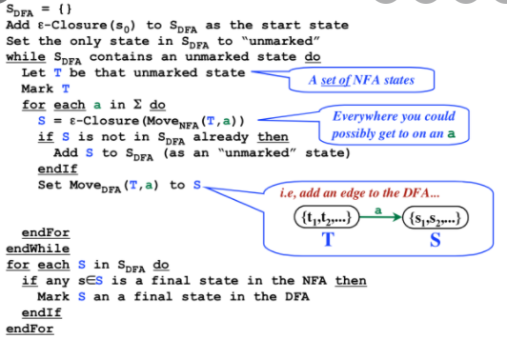

**Solution:**

//Implementation of Lexical Analyzer using Lex tool

%{  
int COMMENT=0;  
%}  
identifier [a-zA-Z][a-zA-Z0-9]*  
%%  
#.* {printf("\n%s is a preprocessor directive",yytext);}  
int |  
float |  
char |  
double |  
while |  
for |  
struct |  
typedef |  
do |  
if |  
break |  
continue |  
void |  
switch |  
return |  
else |  
goto {printf("\n\t%s is a keyword",yytext);}

"/*" {COMMENT=1;}{printf("\n\t %s is a COMMENT",yytext);}

{identifier}\( {if(!COMMENT)printf("\nFUNCTION \n\t%s",yytext);}

\{{if(!COMMENT)printf("\n BLOCK BEGINS");}

\}{if(!COMMENT)printf("BLOCK ENDS ");}  
{identifier}(\[[0-9]*\])? {if(!COMMENT) printf("\n %s IDENTIFIER",yytext);}  
\".*\" {if(!COMMENT)printf("\n\t %s is a STRING",yytext);}  
[0-9]+ {if(!COMMENT) printf("\n %s is a NUMBER ",yytext);}  
\)(\:)? {if(!COMMENT)printf("\n\t");ECHO;printf("\n");}  
\( ECHO;  
= {if(!COMMENT)printf("\n\t %s is an ASSIGNMENT OPERATOR",yytext);}  
\<= |  
\>= |  
\< |  
== |  
\> {if(!COMMENT) printf("\n\t%s is a RELATIONAL OPERATOR",yytext);}  
%%

int main(int argc, char **argv)  
{  
FILE *file;  
file=fopen("var.c","r");  
if(!file)  
{  
printf("could not open the file");  
exit(0);  
}  
yyin=file;  
yylex();  
printf("\n");  
return(0);  
}  
int yywrap()  
{  
return(1);  
}

**INPUT:**  
//var.c  
#include<stdio.h>  
#include<conio.h>  
void main()  
{  
int a,b,c;  
a=1;  
b=2;  
c=a+b;  
printf("Sum:%d",c);  
}

**OUTPUT:**

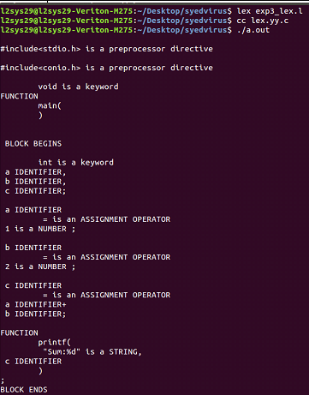

**ASSIGNMENT III**

**Problem Statement**

Implement Recursive Descent Parser for Sample Language

**Objective**

To understand the working of Predictive Parser. Parse the given string using the Predictive Parser.

**Theory**:

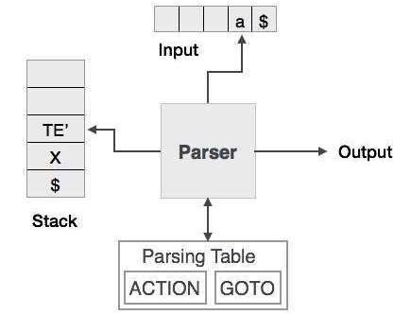

**Solution:** Take any CFG as a input and perform the following steps.

Step 1: Remove Left Recursion from the grammar if any.

Step 2: Left Factorize the grammar if required.

Step 3: Construct FIRST set of items for every Non Terminal.

Step 4: Construct Follow set of items for every Non Terminal.

Step 5: Construct Predictive Parsing Table.

Step 6: Parse the given string using the Predictive Parsing Table.

**Input:** Any CFG as a input

**Output:** Successful / Unsuccesfull Parsing

**ASSIGNMENT IV**

**Problem Statement**

Implement Intermediate Code generation

**Objective**

To learn the different forms of Intermediate Code generation such as Three adress forms: Quadruples, Triples, Indirect Triples, Syntax Tree, Pseudo Code etc

**Theory:**

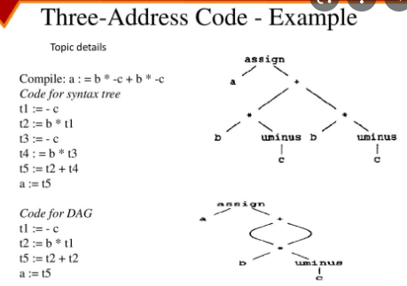

**Solution:**

#include<stdio.h>#include<string.h>void pm();void plus();void div();int i,ch,j,l,addr=100;char ex[10], exp[10] ,exp1[10],exp2[10],id1[5],op[5],id2[5];void main(){clrscr();while(1){printf("\n1.assignment\n2.arithmetic\n3.relational\n4.Exit\nEnter the choice:");scanf("%d",&ch);switch(ch){case 1:printf("\nEnter the expression with assignment operator:");scanf("%s",exp);l=strlen(exp);exp2[0]='\0';i=0;while(exp[i]!='=')  
{  
i++;  
}  
strncat(exp2,exp,i);  
strrev(exp);  
exp1[0]='\0';  
strncat(exp1,exp,l-(i+1));  
strrev(exp1);  
printf("Three address code:\ntemp=%s\n%s=temp\n",exp1,exp2);  
break;  
  
case 2:  
printf("\nEnter the expression with arithmetic operator:");  
scanf("%s",ex);  
strcpy(exp,ex);  
l=strlen(exp);  
exp1[0]='\0';  
  
for(i=0;i<l;i++)  
{  
if(exp[i]=='+'||exp[i]=='-')  
{  
if(exp[i+2]=='/'||exp[i+2]=='*')  
{  
pm();  
break;  
}  
else  
{  
plus();  
break;  
}  
}  
else if(exp[i]=='/'||exp[i]=='*')  
{  
div();  
break;  
}  
}  
break;  
  
case 3:  
printf("Enter the expression with relational operator");  
scanf("%s%s%s",&id1,&op,&id2);  
if(((strcmp(op,"<")==0)||(strcmp(op,">")==0)||(strcmp(op,"<=")==0)||(strcmp(op,">=")==0)||(strcmp(op,"==")==0)||(strcmp(op,"!=")==0))==0)  
printf("Expression is error");  
else  
{  
printf("\n%d\tif %s%s%s goto %d",addr,id1,op,id2,addr+3);  
addr++;  
printf("\n%d\t T:=0",addr);  
addr++;  
printf("\n%d\t goto %d",addr,addr+2);  
addr++;  
printf("\n%d\t T:=1",addr);  
}  
break;  
case 4:  
exit(0);  
}  
}  
}  
void pm()  
{  
strrev(exp);  
j=l-i-1;  
strncat(exp1,exp,j);  
strrev(exp1);  
printf("Three address code:\ntemp=%s\ntemp1=%c%ctemp\n",exp1,exp[j+1],exp[j]);  
}  
void div()  
{  
strncat(exp1,exp,i+2);  
printf("Three address code:\ntemp=%s\ntemp1=temp%c%c\n",exp1,exp[i+2],exp[i+3]);  
}  
void plus()  
{  
strncat(exp1,exp,i+2);  
printf("Three address code:\ntemp=%s\ntemp1=temp%c%c\n",exp1,exp[i+2],exp[i+3]);  
}

**INPUT:**

A<=B

**OUTPUT:**

100 if a<=b goto 103  
101 T:=0  
102 goto 104  
103 T:=1

**ASSIGNMENT V**

**Problem Statement**

Implement Common Sub expression elimination Code optimization technique using DAG.

**Objective**

To learn the different techniques of Code Optimization such as Code Motion, Common Subexpression Elimination, Loop Jamming, Loop Unrolling etc. To study about DAG(Directed Acyclic Graph).

**Theory:**

